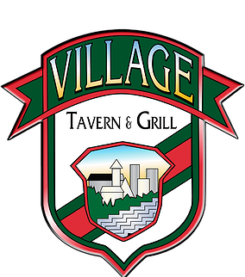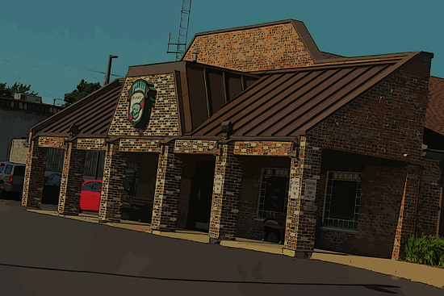

OFFICIAL INVITATION

Eat Out 2 Help Out Special Fund Raising Event

PLEASE SUPPORT OUR EVENT

THIS EVENT IS FOR ____________________________________________________________

DAY _____________________________________ DATE______________________________

LOCATION **The event is scheduled from 11am to 11pm at Village Tavern & Grill of Carol Stream**.

There are two ways to help and support our efforts to raise funds. Visit the restaurant the day of the event and show your server this invitation. If you cannot make the event you can purchase gift cards online anytime during the day of the event and we will get a 20% donation of your purchase. . It’s an all-day event, so you can come for lunch, dinner or both. You can bring your business colleagues from work for lunch and then the family for dinner! Make sure you bring a flyer to each visit!

This flyer must be turned into your server at the time of payment alone with a copy of your bill in order to receive credit for the donation. Once you’ve left the building, you may not return with a flyer to apply to a bill.

Although groups may request sitting in the same section when booking the event, it is not necessary to receive the donation. We may not be able to grant all seating requests. 20% of the pre-taxed bill, minus any discounts will be donated back to the organization including carry-out orders. If your organization is interested in booking an “EAT OUT 2 HELP OUT” event, please call (630)-668-1101

SUB-TOTAL CHECK AMOUNT: $ ________________ SERVER: ______________ TIME:__________________

(Before taxes & discounts)

## Village Tavern & Grill of Carol Stream

## 291 South Schmale Road, Carol Stream, IL 60188

## (630)-668-1101